When Logics create Laddoos

Laddoos are the sweetest significance of India, the place where cultures, traditions bunch together to form a perfect platter. This platter won't miss out laddoos while the Westerns feed with ice creams and cakes for their deserts. Laddoos are innocent balls of joy. They are dry and eaten anywhere.

**Appearance:**

Laddoos constitute pulses, nuts, seeds, fats, and sugar syrup. Rolled between palms carefully, Laddoos shape up to become Spherical in shape. Yes, the **"Sphere-like Spherical shape"** that fill the hungry mouth at one whole cost. The perfect match with a large 'O' shaped mouth and a laddoo groove well.

**Origin:**

India is popular for its cuisines with philosophy. Food habits are well scripture in several manuscripts, Vedas, and religious texts. Among numerous nutritious foods, laddoos aren’t left behind, served with other meals. There is an increase in diabetes. As a result, modern-day warns people to consume sugar. But we must concede the fact that ancient India consumed natural sweetenings such as Jaggery and Honey. Jaggery and Honey are the safest options to substitute Sugar components.

*“Jaggery and Honey are the safest options to substitute Sugar components.”*

**Reason 1:**

If we circulate once more in records, legends advised that the first laddoos were invented in the 4th century B.C by Sushruta, the father of Indian Surgical Procedure and Treatment. The first laddoo was prepared using Sesame seeds, blended with Jaggery, peanuts, and milk fats, It was invented by Sushruta, which we Indians generally call it as, "*Til Ke Laddoo*". **These sesame laddoos consisted of antiseptic properties that treat his surgical sufferers.**

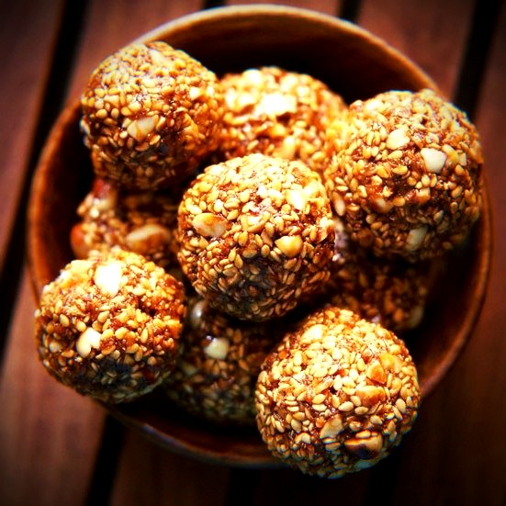

*Sesame Laddoo (or, Til Ke Laddoo)*

**Reason 2:**

There is another logic that prepares these wonderful globulus sweet balls. **The logic revolves around the geometric figure, 'Circle', which is the most spontaneous shapes in the universe. Hindus (ancient Indians) believe circle to be timeless, cyclical, and infinite**; which is a terminal scientific truth resulting in the invention of the number "Zero". This natural figure was the simplest shape any individual could quickly roll out between palms with tender and care, consuming minimum time span.

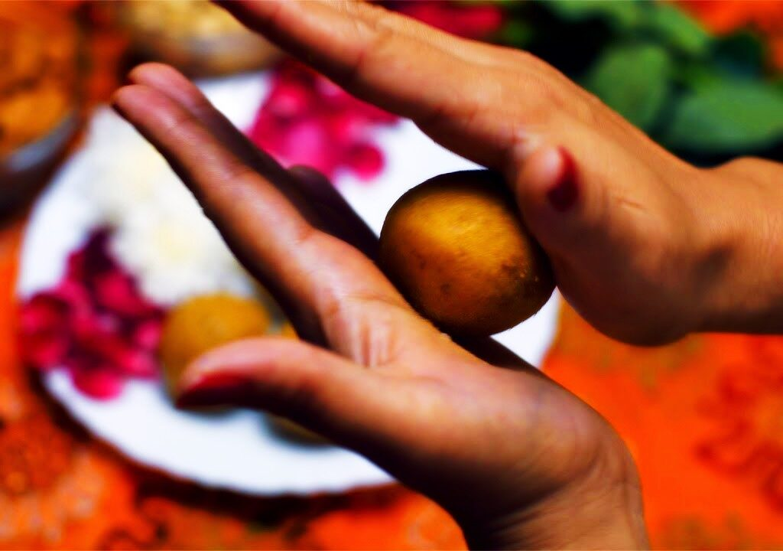*Laddoo being prepared by rolling between palms, tenderly with care. This is believed to be the easiest form to prepare a sweet.*

Somewhere down the road, laddoos got here to become correlated with all things festive, happy, and yummy. Traditional factors to make laddoos have been Ghee (clarified butter), Khoya, and Jaggery. A turning element for laddoos got here with the introduction of sugar within the recipe, and later the mass cultivation of sugar all through the country. Honestly, nowadays laddoos don't signify medicinal properties, they have just turned out to be one of the most appealing delegations of India.

Next time you hear laddoos, you will definitely remember the history I narrated you. You won't go wrong! [Click here for more delicious food blogs.](https://thinknsay.in/category/food/) You can also find me writing [blogs on Movies](https://thinknsay.in/category/movie/). I am sure it will be an eye-opening context for you.